cmMALAWI UNIVERSITY OF SCIENCE AND TECHNOLOGY
PHYS-111 Lecture 3 Tutorial questions
- An airplane flies 250 km due west from city A to city B and then 420 km in the direction of 60 degrees north of west from city B to city C.
(a) In straight-line distance, how far is city C from city A?
(b) Relative to city A, in what direction is city C?
- A commuter airplane starts from an airport and takes the route shown in Figure below. The plane first flies to city A, located 175 km away in a direction 30.0 north of east. Next, it flies for 150 km 20.0 west of north, to city B. Finally, the plane flies 190 km due west, to city C. Find the location of city C relative to the location of the starting point.
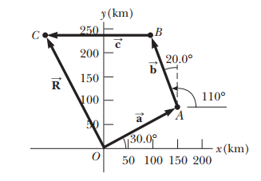
- Show that the maximum height of a projectile is given by y_{max} = $\frac{{V_{i}}^{2}{Sin}^{2}θ_{i}}{2g}$
- A projectile is fired from the ground with an initial velocity $V_{i}$ initial angle $θ_{i}$ lands on the same level as it was fired. Show that;
- Show that the range R of the projectile is $R= \frac{{V_{i}}^{2}Sin 2θ_{i}}{g}$
- Determine the maximum range $R_{max}$ of the projectile and the angle at which the maximum range occurs.
- A projectile is fired in such a way that its horizontal range is equal to three times its maximum height. What is the angle of projection? Give your answer to three significant figures.
- A firefighter 50.0 m away from a burning building directs a stream of water from a fire hose at an angle of 30.0° above the horizontal. If the speed of the stream is 40.0 m/s, at what height will the water strike the building?
- A soccer player kicks a ball horizontally off a cliff 40.0 m high into a pool of water. If the player hears the sound of the splash 3.00 s later, what was the initial speed given to the rock? Assume the speed of sound in air to be 343 m/s.
- A boy can throw a ball a maximum horizontal distance of 40.0 m on a level field. How far can he throw the same ball vertically upward? Assume that his muscles give the ball the same speed in each case.
- A stone thrown off a bridge 20 m above a river has an initial velocity of 12 m/s at an angle of 45 degrees above the horizontal. The stone lands in the river below.
(a) What is the range of the stone?
(b) at what velocity does the stone strike the water?
- A basketball player throws a ball to score through the ring as shown in the figure below. Determine the time taken for the ball to just pass through the inside of the ring.

